**In app Purchase ios Swift**

Login at : <https://developer.apple.com/account/>

After login scroll down and go to Identifiersunder Certificates and Id's

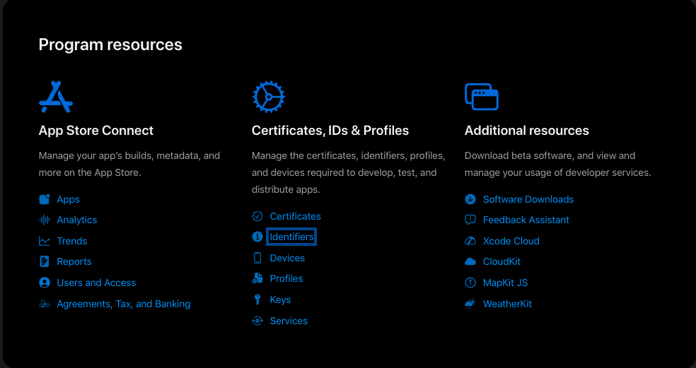

Click om +Sign to add an identifier and select ​​App ID and click continue

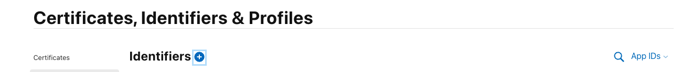

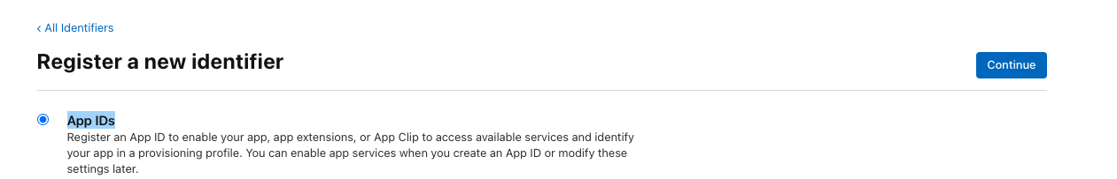

Select Type app and click continue

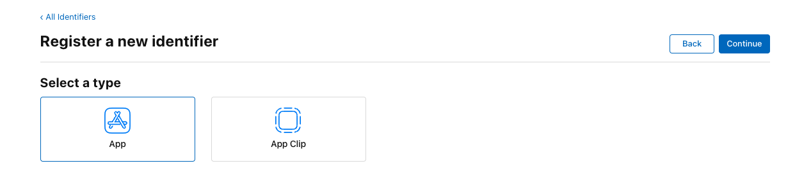

Add description and Bundle ID of the app and select the options as per requirements

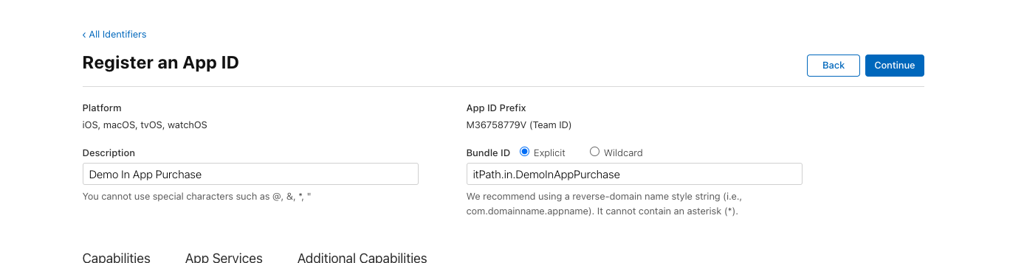

Click continue and register

Now go to the: <https://appstoreconnect.apple.com/>

Click on My Apps

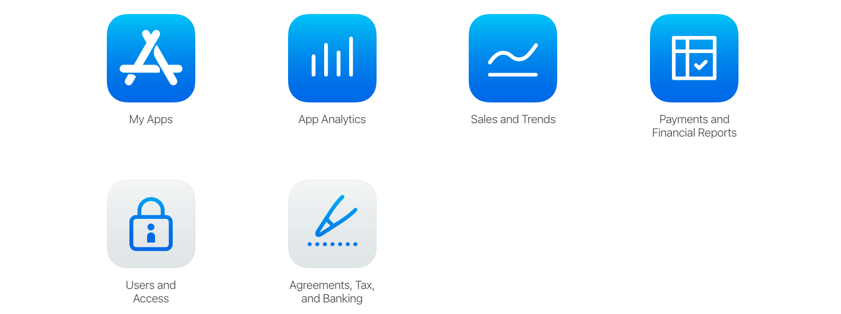

Click on + and Select New App

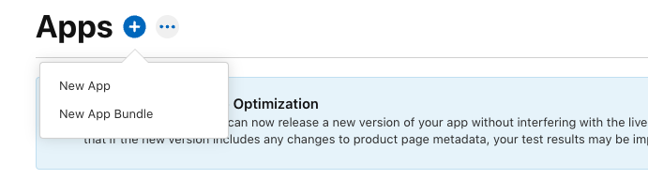

Select the required platform

In side Name write the name of the app

Select primary Language as per requirement

Select the bundle id that we have added earlier

Inside SKU Write an Unique code

Click on the create button

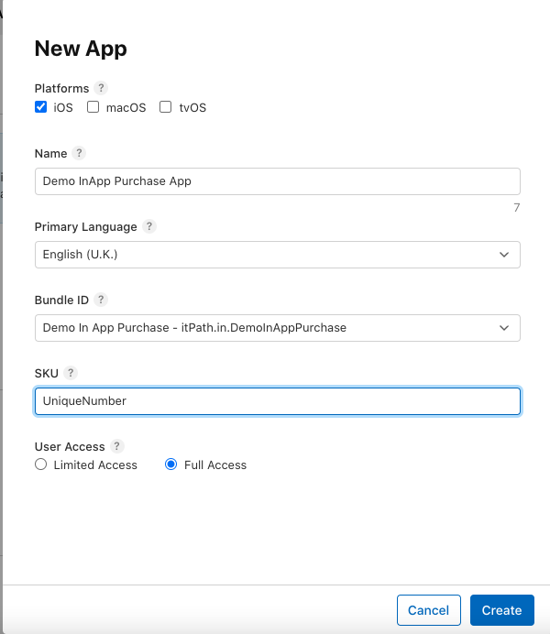

Click on the In App Purchases and Click to create

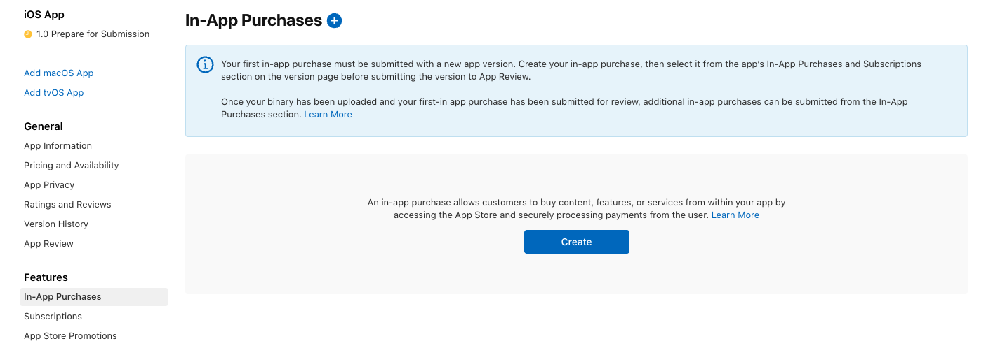

Select the in app purchase type as per requirements

**Consumable**: Gems or Coins in games

**Non-Consumable**: Character outfit, Gun Skins

In the reference name, add the reference you want to give

Inside product id add bundleID.refrenceName which is the standard procedure but you can give anything which should be unique

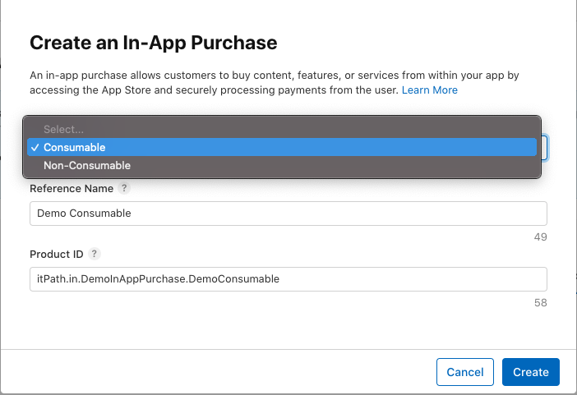

Setup the availability , in which countries that in app purchase is available and select the countries as per your requirements

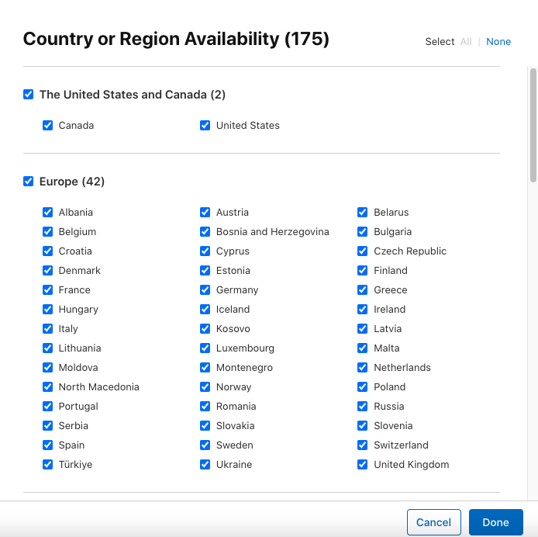

Select the base country in which you want to add the price, apple will automatically adjust the price in different regions read all descriptions carefully

After selecting the base country and price Click on next/continue

After that you will be redirected to the page where you can set prices for the different countries

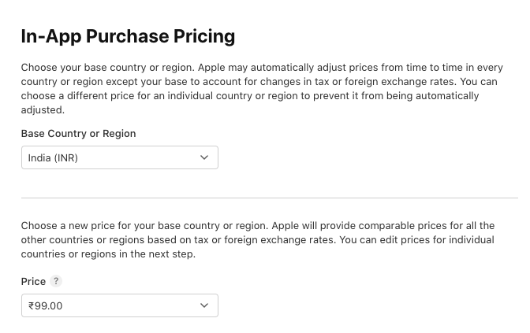

Select price and click on next and confirm

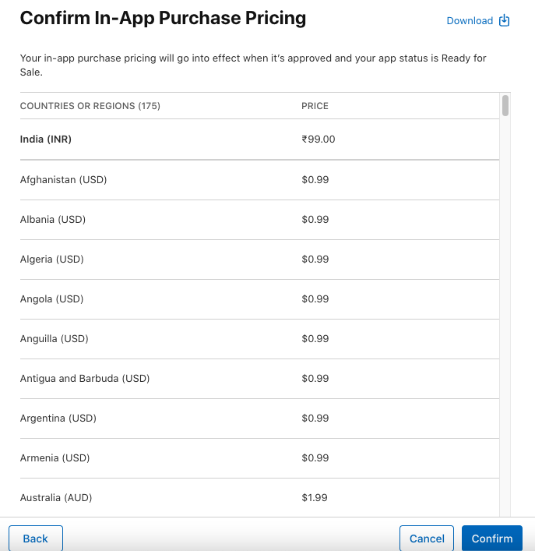

In app store localization click on Add localization

The default language of in app purchase

Inside Display name write what users will see while purchasing and same goes for the description

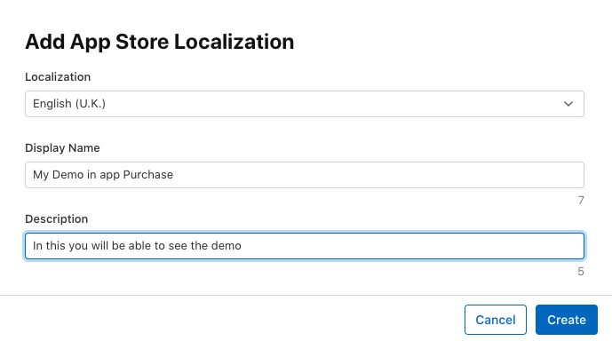

After all this click on save , your in app purchase is ready , but it will show missing metadata as we have not added the screenshot where we are doing the in app purchase.

After all the above steps, call the below function where you want to add the purchase functionality

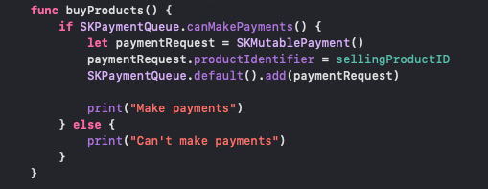

Additionally just declare the below function to track the payment status, if you want to just track the purchased products store that product into the UserDefaults

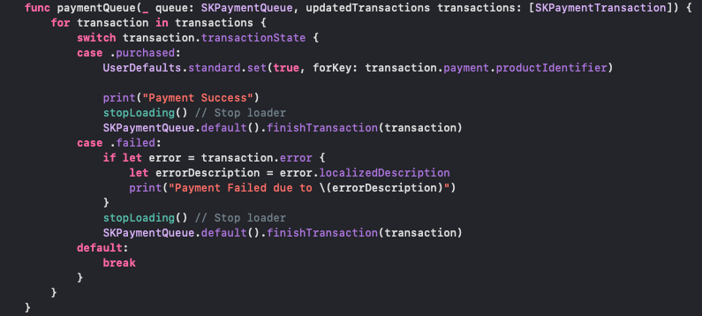

If the account has already purchase but somehow its data is cleared then we need to add just a line to retrieve back it's all purchases



**Subscriptions**

For subscriptions go to the: <https://appstoreconnect.apple.com/apps/>

From that select subscriptions and click on create

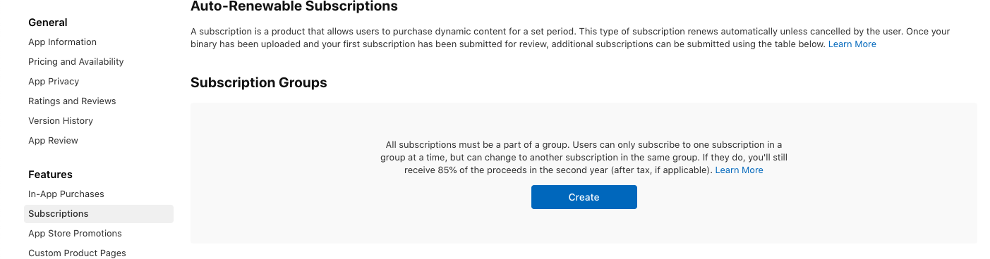

We are doing for auto subscriptions renewal but for non-renewal subscriptions the process is the same, just click on manage as shown below:

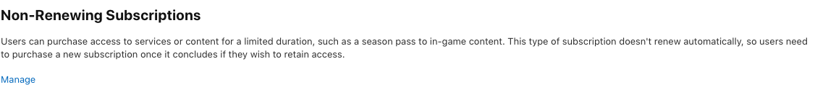

Create the subscription group

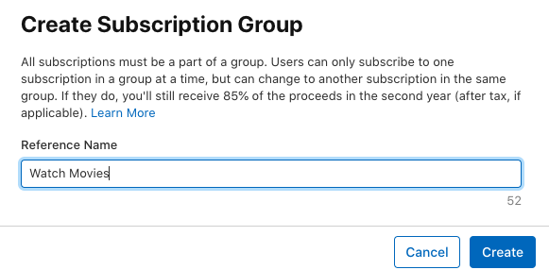

After creating the subscription groups click on create and create the subscriptions:

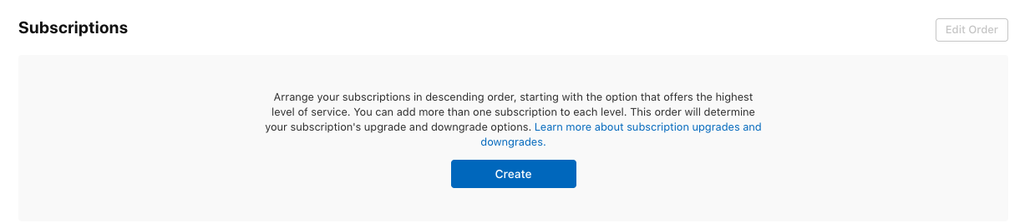

Fill the details as we filled for the renewable products:

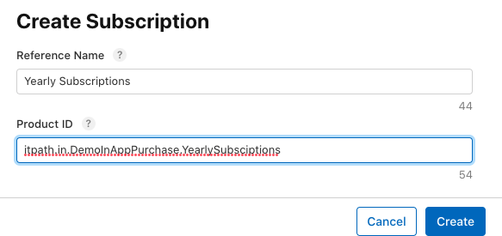

Select the subscription duration as per the requirement

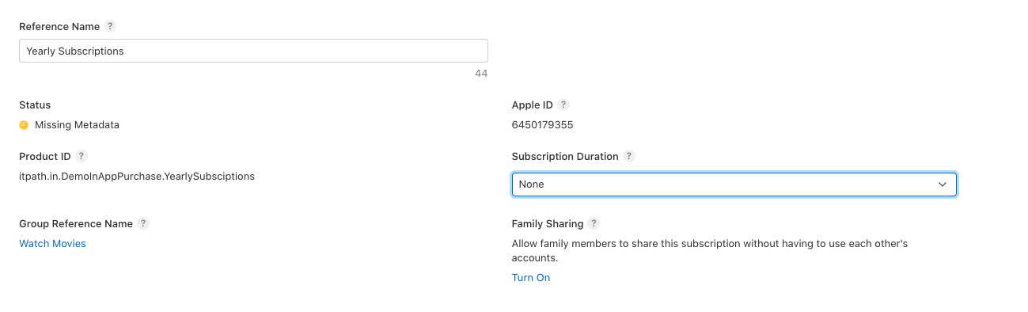

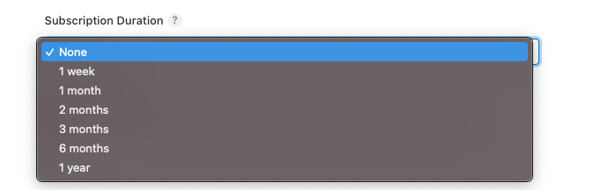

Availability, prices and Localization remains the same as we did for renewable products

Also the subscription also works the same just we need to pass the Id of the product to be purchased.